**Escape Room Season 1: System Design Document**

# Objective

This document provides information on the Escape Room Season 1 project, which will be called **Escape Room 1** and **System** in this document. This document was created with long-term storage of the project between uses and maintenance of the System. This document is subject to change due to modifications to the Escape Room 1 project. NOTE: This document does not discuss puzzle ideas or reasoning behind the final implemented puzzles.

The parts of Escape Room 1 this document discusses include hierarchy of system devices, languages used in programming the system and coding practices thus, setup of system devices, maintenance of the System for general use and when modifying system devices, wiring of the System, and budget of the Escape Room 1 project.

## Background

This project’s main objective was to create an escape room using a large amount of technology not usually found in escape rooms, which is why this section will briefly describe the basic principles and general setup/goal for an escape room.

The basic principle of an escape room is that it is an activity where an individual or a group of individuals are placed within a space which is usually a room within a building or an entire building depending on the escape room scope that tends to be filled with puzzles and a countdown timer. The escape room activity usually ends when the timer runs out of time or when the individual(s) solve all the puzzles within the escape room space.

The general setup of an escape room is a room that is filled with props to setup the story environment, and props to use to solve puzzles located within the room. There tends to be smaller puzzles (**sub-puzzles**) that are subsections of one larger puzzle, which is the overall goal of the escape room. All puzzles are planned out by the escape room designer and are usually designed to take an average person the full time on the timer to solve all of the puzzles. The difficulty also depends on the escape room designer; the previous sentence is the most often setup preferred by escape room designers.

# System Overview

Escape Room 1 deals with a variety of devices that can be viewed in the Budget section of this document. The overall hierarchy structure of the System can be viewed in Figure 1 and begins with a Raspberry Pi 2 model A (a.k.a. Pi) which contains the logic for the System’s puzzles. This primarily deals with both device to device, and puzzle to puzzle transitions. In general terms, the Pi coordinates device interactions within a smaller sub-puzzle in order to manage and complete the sub-puzzle as well as coordinates transitions between sub-puzzles in order to complete the larger puzzle. The Pi tends to do this by sending strings containing command codes via Bluetooth to various micro-controllers. In this project, we use 4x Arduino Mega 2560s rev2 with HC-05 Bluetooth modules which are capable of both master and slave modes as our micro-controller of choice. The Pi also manages a keyboard and a display for output, which can be used for either admin use or for Escape Room 1 puzzles.

As mentioned in the previous paragraph, there are 4 Arduinos used in the System for the primary use of managing devices necessary for the functionality of Escape Room 1. These are generally then grouped into locations where the devices will be used and same devices are grouped together as much as possible. There are 2 Arduinos located within a Box container and for easier reading, the first Arduino will be called the NFC Arduino and the second Arduino will be called the Main Cube Arduino. There are also 2 Arduinos that handle other devices elsewhere in the room and these will be called the Magnet Arduino and the Laser Arduino. These Arduinos manage the majority of devices needed within Escape Room 1, which include but is not limited to lasers, NFC reader, solar cells for sensors, and a keypad. For a more in depth list, please refer to the Budget section.

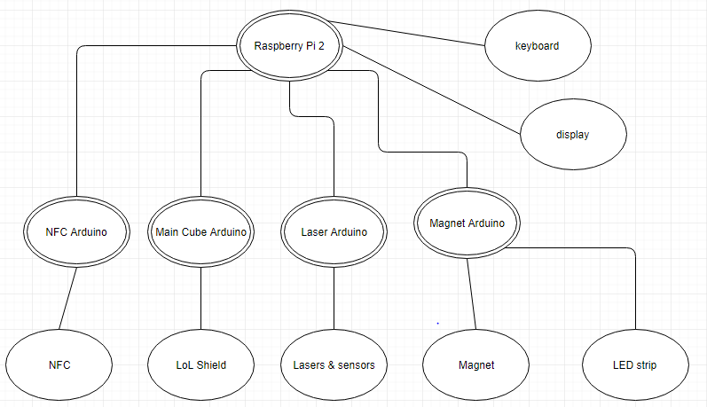

Figure 1: Device Structure of Escape Room 1.

# Programming the System

There are 2 main programming languages used within the System. Python was used to program the Pi because there was a large pool of python examples provided online by the Raspberry Pi & Python community and it provided easy implementation for various puzzle options that were thought of in the System Design stage, but are not implemented in the final product. The programming in the Python script includes Bluetooth communication between the Pi and the various Arduinos, unicurses for display using Python, and the logic for sub-puzzle/escape room completion.

To program the Arduinos, the Arduino library and language was used which contains a c++ similar language. The NFC Arduino handles all transmitting CAT5 puzzle pieces, PN532 (Arduino capable NFC reader/writer), 12 LED ring, and the cube inner light. The Main Cube Arduino handles displaying the necessary lit lights on the LoL shield, keypad membrane, and receiving all CAT5 puzzle pieces. The Magnet Arduino handles an electromagnet, LED strip for lighting within the room, and 5 servo motors. The last Arduino, the Laser Arduino, manages the sensors, lasers, small LED diodes, and a PanTilt servo motor. The specific programs can be found in the Appendix of the document or in the Escape Room code repository/google drive.

## Coding Practices

# Setup of System Devices

# Maintenance

## General Maintenance

## Maintenance for Adding/Removing Devices

# Wiring and Enclosures

# Budget

# Conclusion

Any maintenance for Escape Room 1 should be doable with reference to this document, and fair amount of information should be given to reproduce this project at any given time with respect to devices used and functionality of devices. Feel free to modify the length of wire used and enclosure for devices used.